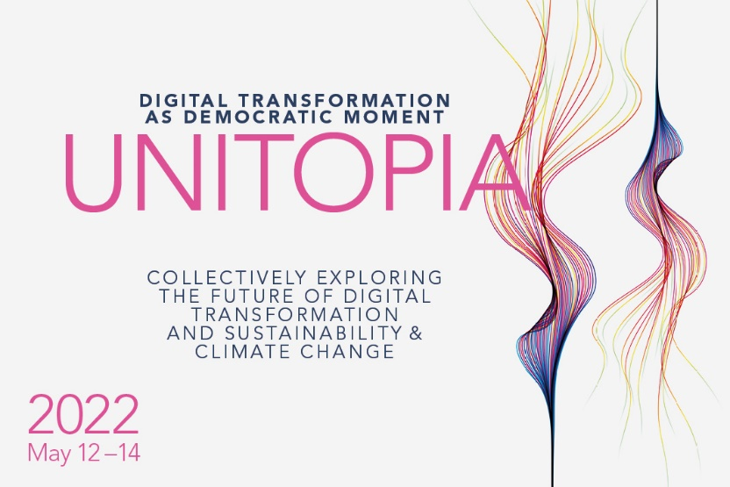
Please rename the file with Call for Workshops_UNITOPIA2022_Name_Title.
Submit the document as .doc file and do NOT convert it to PDF. Thank you!

Digital Transformation as Democratic Moment: Call for Workshops

Abstract Submission
Type  (please choose one) | CONCEPTUAL AND ACADEMIC WORKSHOPS / SKILLS WORKSHOP
Author Name(s) & Affiliation(s)
ARQUS Alliance member | YES / NO
Workshop title
Workshop description (max. 500 words) | The abstracts should contain a short introduction to the topic, the central question tackled in the workshop, a short description of the workshop’s format (eg group discussion, paper workshop, etc), needed infrastructure for hosting the workshop, and how it contributes to an ongoing discussion. Since the conference understands itself as an interdisciplinary event, these are just some guiding bullet points. However, we highly encourage you to keep a diverse audience in mind when formulating the abstract.

