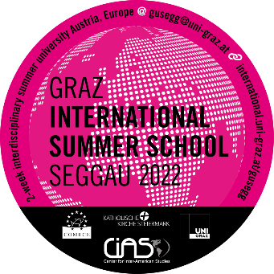
APPLICATION FORM

Graz International Summer School Seggau
(GUSEGG)
2022

Personal Details
Picture: | (insert your picture here)
Title (Mr/Ms/Mrs/Dr etc):
Surname:
First Name:
Address:
Postal Code:
City:
Country:
Telephone Nr.:
E-Mail:
Alternate E-Mail:
Date of birth (dd/mm/yyyy):
Gender (m/f/o):
Country of birth:
Citizenship:
Country of permanent residence:
Passport number:
Issued by:
Date of issue:
Valid until:
In case of emergency, please contact:
(Name, address, phone number, relationship of the person we should contact)
Academic Details
Fill in the required information of your current studies:
Current field of studies:
Name of University:
Faculty:
Level of study at home university (BA/MA/PhD/under-graduate/advanced):
Fill in the required information of your completed or other studies (if existing)
Name of University:
Faculty:
Level of study at home university (BA/MA/Diploma program/PhD/others):
If you have ever studied at an Austrian university, please state your Matrikelnummer:
Academic stays abroad:
Professional experience:
Professional objective(s):
Do you wish to undertake assessment for academic credit? (yes/no):
Do you require this summer school to count towards your degree? (yes/no):
Are you currently working on a diploma thesis/dissertation/research project?
Seminars
Please rank GUSEGG 2021 seminars in order of your preference
- Choice
- Choice
- Choice
- Choice
- Choice
- Choice
Recommendation
The two letters of recommendation I enclose were issued by these university teachers (name, institution, e-mail contact)
Language Skills
Native Language(s):
Please state if your language skills in the languages listed below are very good, good, or basic
English (obligatory!)
German
Other:

Please read the following conditions carefully and confirm them by signing below:
- I read the instructions regarding the application process and enclosed all required documents. I understand that my application will NOT be considered in case of missing documents.
- I understand that the Graz International Summer School Seggau is NOT an English language program and guarantee that my English skills are on a level which allows me to actively engage in academic discourse.
- I understand that in case of acceptance it is obligatory for me to attend all classes which means that I will be present from July 4th to July 10th (we will NOT accept latecomers or students who need to take time off during this one week!)
- I understand that the transfer recognition of any credit received for the program is subject to determination by my home university.
- I understand that in case of acceptance I have to pay the summer school fee until April 23rd, 2021 and that my spot will only be held as long as my fee is paid in full by this deadline. (Under no circumstances will I be admitted to the program unless my fees have been paid in full)
- I understand that only 80% of my tuition fee will be refunded in case of:
- Illness (provided that a medical report is presented)
- Severe illness or death of a close relative (i.e. parent, spouse/partner, children, sister or brother – provided that a medical report is presented!)
There is NO reimbursement for any other reasons!
- I understand that the organizers reserve the right to cancel or amend the Summer School for reasons of viability or due to any other unforeseen circumstances, in which case any fees paid will be refunded in full.
- FOR PARTICIPANTS ON-SITE ONLY:
I confirm that my health and accident insurance is valid for Austria.

Signature, place and date:

_______________________________________________________________________________

