Outreach activities of the Sub-Point Graz
Hannes Mayer

Asteroid Day is a global awareness campaign where people from around the world come together to learn about asteroids and what can be done to protect our planet, families, communities, and future generations from future asteroid impacts. Regionally organised large and small events were held on June 30th – from live concerts and community events, to lectures and other educational programmes. The Sub-Point Graz organized a very small poster exhibition on legal issues concerning asteroids and planetary defence outside its office on the campus of Karl Franzens University Graz.
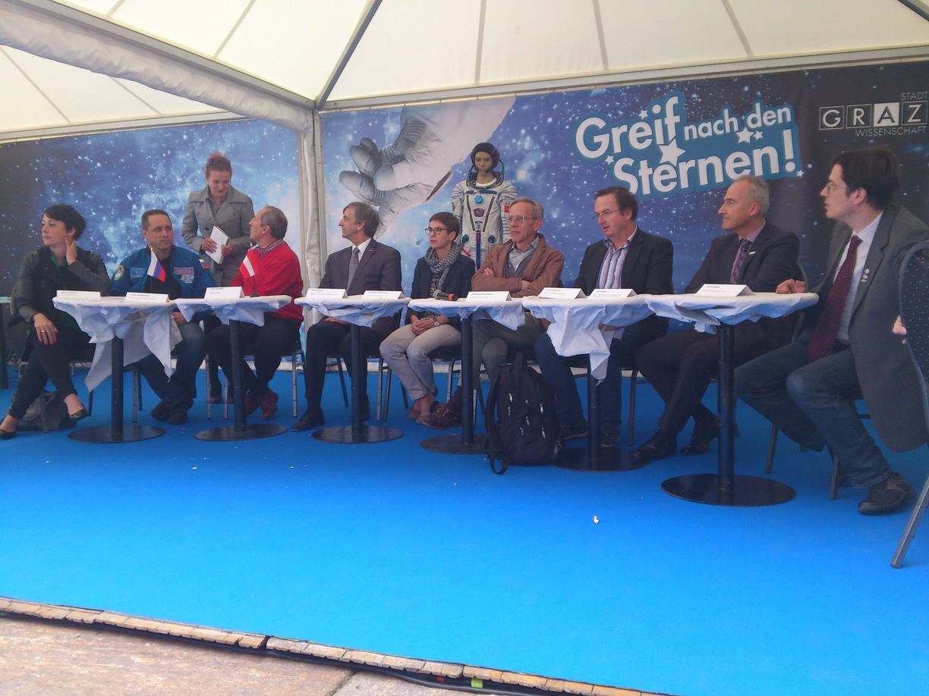
After last year’s successful 1st Graz Space Day, the space institutions from Graz again had the chance in the 2nd Graz Space Day this year. Visitors could learn about space law in a “world café”-style workshop and Sub-Point contributor Hannes Mayer took part in a public panel discussion on spaceflight and space research.
The Sub-Point Graz once again cooperated with the Austrian Space Forum for the 2014 World Space Week, supporting space outreach activities at two Styrian Schools, BORG Monsberger and Skiakademie Schladming. Students at the Skiakademie discussed possible implications of the discovery of alien life and market planetary real estate, while students of BORG Monsberger went on a scaled down tour of the solar system following the paths of Voyager 1, Rosetta and New Horizons.

