Planetary Defense Conference 2015
Hannes Mayer
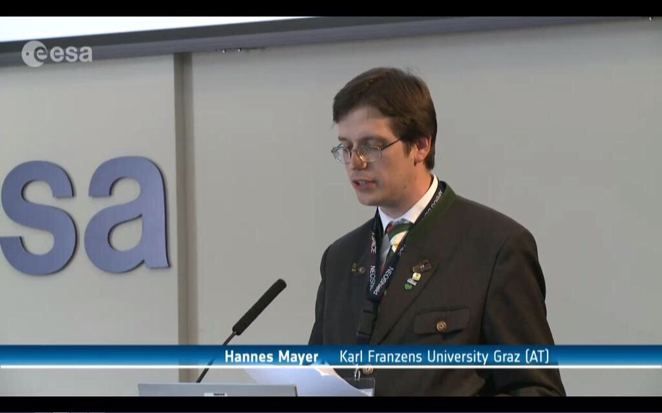
The International Academy of Astronautics Planetary Defense Conference is a scientific conference held bi-annually bringing together the world’s experts on all aspects of the asteroid threat to Earth. The 2015 Planetary Defense Conference was held at the premises of the European Space Research Institute in Frascatti, Italy. The focus is hereby on five main aspects: finding potentially threatening asteroids and comets, tracking them, characterizing them, deflecting them as well as international coordination and education. In the latter case this included a variety of activities from coordinating observations, to planning for how countries will work together when deflection is needed, to disaster preparedness for the cases where we get surprised by an impact, or where we only have hours, days, or weeks until impact.
The range of participants included representatives of space agencies, industry, research organizations, military and academia. Sub-Point Graz contributor held presentation on the question of the necessity of a special legal regime for planetary defence measures that was very well received.

